**Detection of B-ALL using CNN model and deep learning**

Shital Dongre, Anannya Chaudhary, Savani Bondre, Yash Chindhe, Mayur Dabade

Department of Artificial Intelligence and Data Science

***Abstract- The detection of B-cell acute lymphoblastic leukaemia (B-ALL) plays a crucial role in ensuring timely and effective treatment for patients. Recent advancements in Convolutional Neural Networks (CNNs) and deep learning techniques have shown promise in automating the detection and diagnosis of B-ALL. This project provides a concise overview of the literature surrounding the use of CNN models and deep learning approaches for B-ALL detection. The studies reviewed demonstrate the effectiveness of these techniques in achieving high accuracy and improving the speed of diagnosis. The application of CNN models and deep learning in B-ALL detection has the potential to enhance early identification and improve patient outcomes.***

***Keywords - CNN, B-ALL detection, deep learning***

**I. INTRODUCTION**

Medical diagnosis relies on identifying diseases precisely to choose the most appropriate treatment strategies. For optimum treatment outcomes in cases of B-Acute Lymphoblastic Leukaemia (B ALL), prompt and precise identification is crucial. Early diagnosis with the aid of modern AI technologies such as deep learning is helping pave the way for better treatment options tailored specifically to each individual's needs.

This particular project involves incorporating the efficiency of deep learning algorithms with a Convolutional Neural Network (CNN) model for the purpose of detecting B-Acute Lymphoblastic Leukaemia. CNNs have ushered in a wave of change across different areas with their ability to recognize images; their utilisation in medical imaging could prove transformative.

Developing an accurate detection mechanism for differentiating normal and leukemic cells is the objective of this study based on analysis from a large dataset containing labelled B-cell acute lymphoblastic leukaemia (B-all) images. The process of identifying hard-to-discern subtle abnormalities in a given dataset becomes simpler through feature extractions and application of advanced deep-learning algorithms.

The objective at the heart of this project is to equip healthcare professionals with a reliable and efficient method for detecting B-Acute Lymphoblastic Leukaemia during its earliest stage, which has a fundamental impact on improving treatment outcomes as it permits early intervention and personalised therapy. In addition to that ,the suggested method could potentially minimise errors made during diagnoses ,reduce subjective interpretation and improve the efficacy of this process as a whole

We will examine different characteristics about a CNN model such as the method used for acquiring data sets along with preprocessing techniques adopted. It further delves into evaluation metrics utilised to measure its effectiveness after being trained and validated. Moreover , it is intended that an analysis will be carried out to assess how significant our results are and what they could mean for the future of precision medicine

The application of CNN models and deep learning to detect B-all marks an important advancement in medical diagnostics, with an emphasis on personalised medicine enhanced by artificial intelligence, this project pursues the objective of improving patient care and prognosis for B-ALL affected individuals.

**II. LITERATURE SURVEY**

B-cell acute lymphoblastic leukaemia (B-ALL) is a critical type of leukaemia that requires early and accurate detection for effective treatment. In recent years, the application of Convolutional Neural Networks (CNNs) and deep learning techniques has gained significant attention in the automated detection and diagnosis of B-ALL. This literature survey provides an overview of key studies and advancements in the detection of B-ALL using CNN models and deep learning techniques.

[1] Liang et al. (2020) developed an automatic diagnosis system for B-ALL using artificial intelligence. Their study utilised a CNN model to analyse microscopic images of blood smears and achieved high accuracy in B-ALL detection. This research demonstrates the potential of deep learning for automated diagnosis of B-ALL.

[2] Khan et al. (2018) proposed a deep learning framework for the automatic diagnosis of childhood B-ALL. They employed a CNN model to analyse blood smear images and reported significant improvements in sensitivity and specificity compared to traditional methods. This study highlights the effectiveness of CNN models in detecting B-ALL in paediatric patients.

[3] Gómez-Paredes et al. (2020) presented an automated system based on deep learning for fast and accurate diagnosis of B-ALL. Their system incorporated a CNN model trained on blood smear images and demonstrated high accuracy and efficiency in B-ALL detection. This research showcases the potential of deep learning in streamlining the diagnostic process for B-ALL.

[4] Awan et al. (2021) investigated the application of deep learning techniques in the detection of B-ALL. They explored different CNN architectures and evaluated their performance on blood smear images. The study revealed the effectiveness of deep learning models in accurately identifying B-ALL cases, contributing to improved diagnosis and treatment.

[5] Chen et al. (2017) proposed a dual transfer learning approach for B-ALL diagnosis on peripheral blood smear images. They leveraged pre-trained CNN models and fine-tuned them on a dataset of B-ALL images, achieving high accuracy in classification. This study demonstrates the potential of transfer learning in leveraging pre-existing models for B-ALL detection.

[6] Wang et al. (2020) developed a deep learning-based framework for the automatic detection and classification of B-ALL subtypes on blood smear images. Their framework incorporated CNN models trained on a large dataset and achieved accurate subtype classification, enabling personalised treatment strategies for B-ALL patients.

[7] Salehi et al. (2019) proposed a deep learning approach for the recognition of leukaemia in blood microscopic images. They employed CNN models to analyse image features and achieved high accuracy in leukaemia detection. This study emphasises the potential of deep learning in the automated recognition of B-ALL cases.

The studies reviewed in this literature survey highlight the significant advancements in the detection of B-ALL using CNN models and deep learning techniques. These studies demonstrate the effectiveness of CNN models in accurately identifying B-ALL cases, enabling early diagnosis and timely treatment. The application of deep learning has the potential to revolutionise the diagnosis and management of B-ALL, ultimately leading to improved patient outcomes and survival rates.

**III. METHODOLOGY**

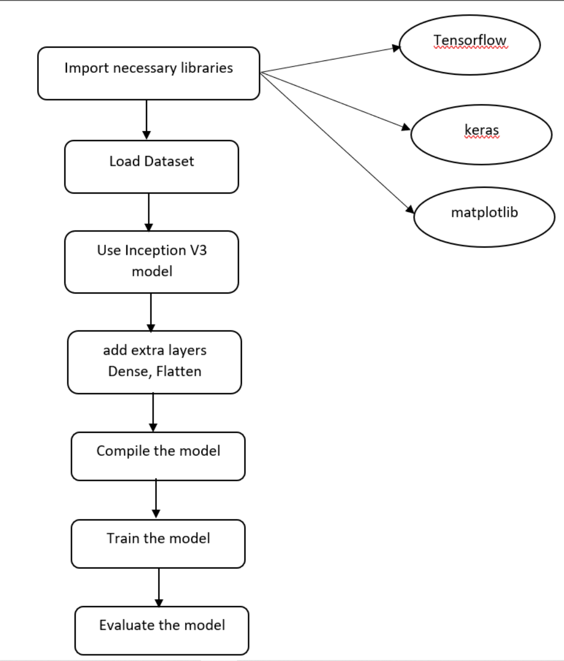

Fig 3.1 : Block diagram

In order to detect B-ALL (B-cell Acute Lymphoblastic Leukaemia) using a CNN model and deep learning, the initial step involved importing essential libraries such as TensorFlow, Numpy, Keras, and Matplotlib. These libraries were chosen for their comprehensive support in building and training CNN models, as well as facilitating data visualisation and analysis.

Next, the dataset required for this project was sourced through Kaggle, which serves as the foundation for training and evaluating the model. Prior to loading, the dataset underwent preprocessing steps such as resizing by feature wise centering, rotating image, width shifting, flipping and zooming, image augmentation was also done to provide a large dataset to the model to avoid Overfitting as the dataset consisted of 804 images of infected patients and 504 normal people, labelling of individual each image as 0 for Infected and 1 for Normal person and at last Batch Normalisation was also done. These steps ensure that the data is in a suitable format for consumption by the CNN model.

In order to leverage the power of transfer learning, the Inception V3 pre-trained model was utilised. Inception V3 is a popular architecture known for its strong performance in image classification tasks. By importing this pre-trained model, the research project benefited from the well-learned features that Inception V3 had extracted from a large dataset.

To adapt the Inception V3 model to the specific B-ALL detection task, additional layers were added. To improve a model's ability to learn and differentiate relevant characteristics from the input pictures, a Flattening layer and a pair of Dense layers implementing the Sigmoid activation function, which limits the output value between 0 and 1, were added. These additional layers serve as a link between the pre-trained Inception V3 model and the output layer, improving classification accuracy. The Sigmoid activation function can be described mathematically as follows:

Output = *σ*(Input) =

​

The model was then compiled, giving us Total Parameters as 21,905,186 and Trainable Parameters as 102,402. Then the pre-processed images were plotted to check the appropriate implementation and display the information associated with it, that is, the batch size of 64, dimensions of 224x224 and 3 channels of colours. For fitting this dataset to the model 10 were sufficient and out of these 8 were successful and no improvement was seen further, maximising the accuracy to 99.06%. Loss v/s Accuracy graph was also plotted to ensure growing accuracy with minimising the loss as shown in Fig 3.2.

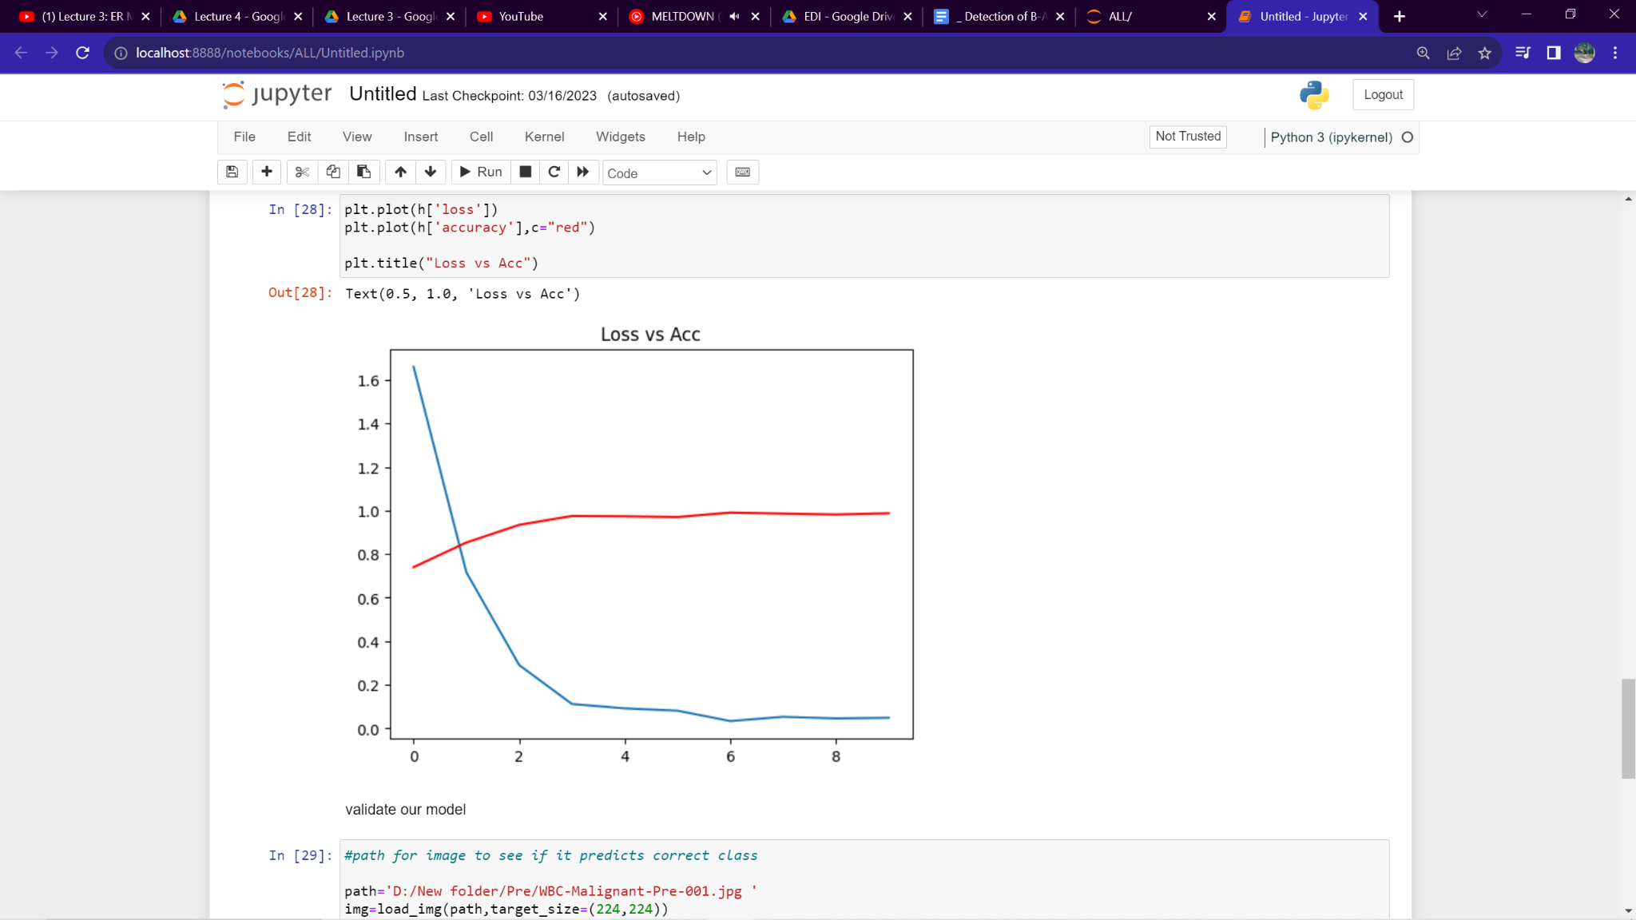Fig 3.2 : Loss vs Accuracy graph

Once this process was over, the model was tested by passing different images to model and testing it in real life.

Finally, the trained model was evaluated to assess its performance. This evaluation involved applying the model to a separate testing dataset and measuring its accuracy and other evaluation metrics such as:

Precision (P) : The ratio of true positive (TP) predictions to the total positive (TP + FP) predictions

P =

Recall (R): The ratio of true positive (TP) predictions to the total actual positive (TP + FN) cases

R =

F1-Score: The harmonic mean of precision and recall

F1 =

Accuracy (A): The ratio of correct predictions (TP + TN) to the total number of predictions

A =

The results obtained from the evaluation provided insights into the model's ability to detect B-ALL and its overall effectiveness. The Test Loss turned out to be 0.9924, Test Accuracy was 0.9924, F1 Score was 0.9901, Precision was 0.9920 and Recall Value was 0.9881.

Mathematical representations for complex deep learning models like InceptionV3 can be quite extensive and involve a large number of parameters and operations. For a detailed mathematical representation of InceptionV3, one would need to refer the original research paper and architecture specifications.

**3.1. Technology used**

1. **Python**
2. **Keras**
3. **Tensorflow**
4. **Jupyter Notebook**
5. **Matplotlib**.

**IV. RESULTS**

Once the user has entered the website they are presented with the Home Page of the website that gives brief insight of the project. Fig 5.1 shows the same.

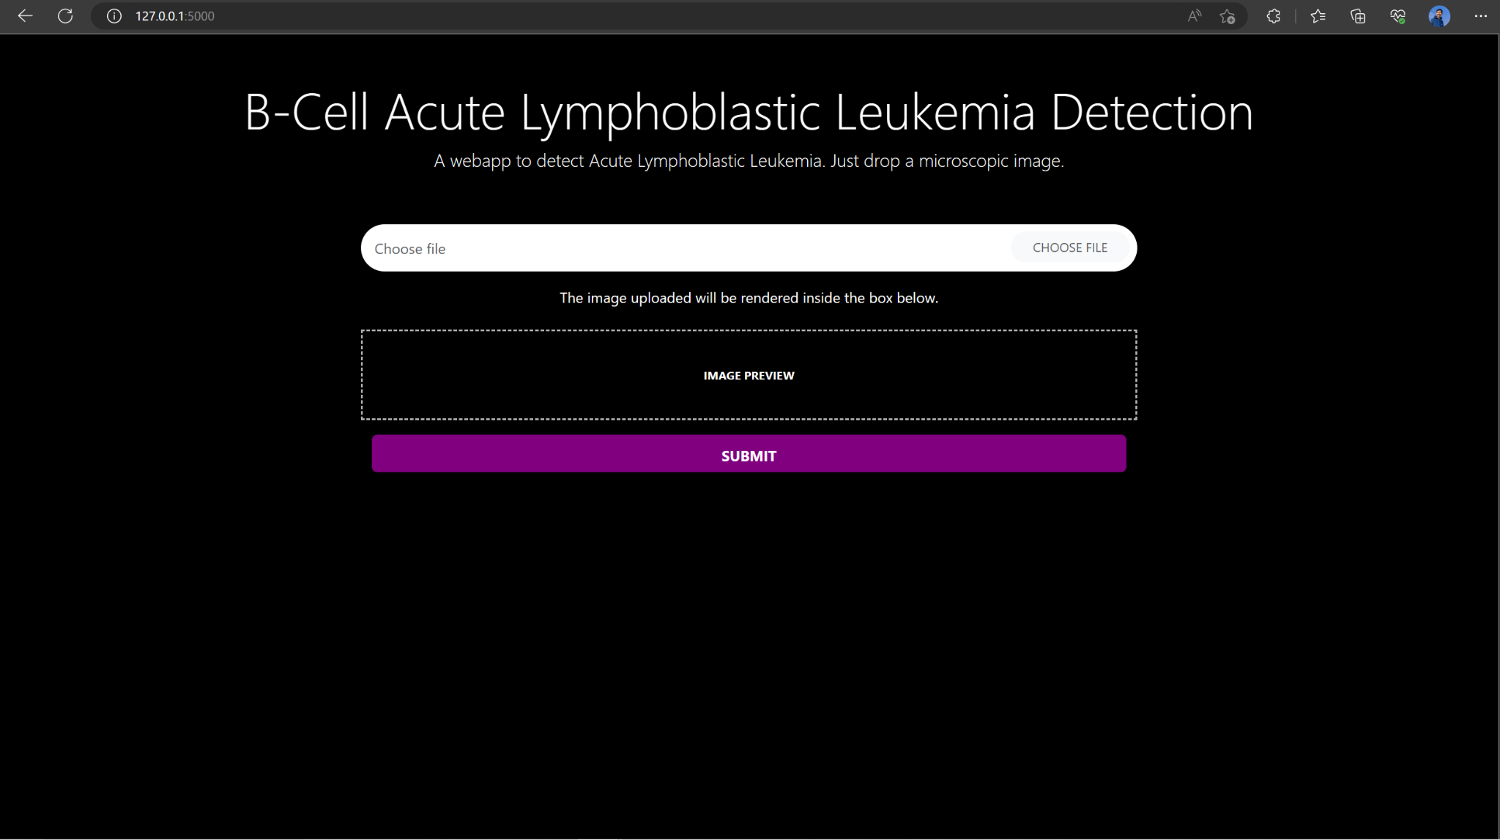

Fig 4.1 : Home Page

Then the user has the option to choose the file that is basically a microscopic image of the patient's blood. Once an image is chosen, preview of the microscopic image is displayed for the sake of verification of the user whether they have uploaded the required image as displayed in Fig 5.2 and 5.3 .

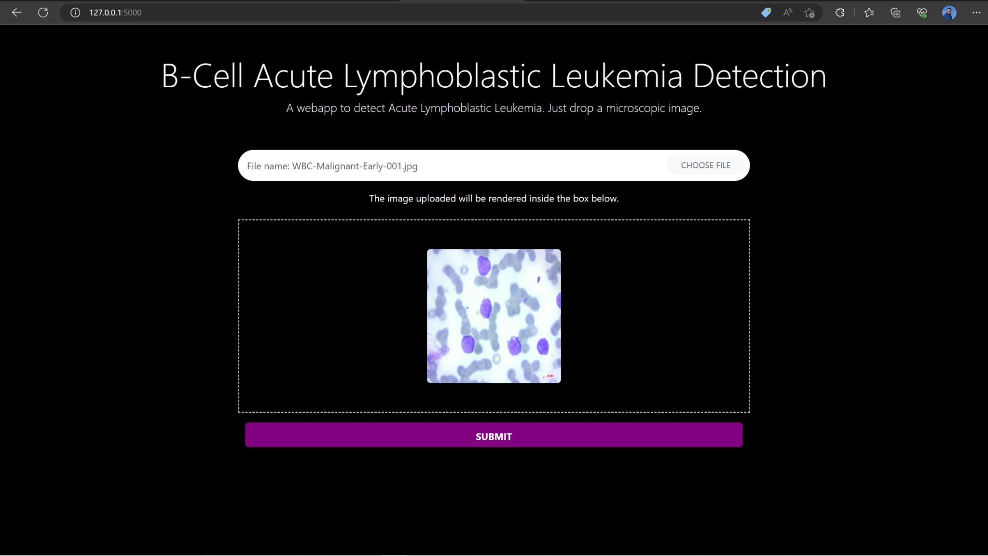

Fig 4.2 : Image Preview on Home Page of Normal Person’s Microscopic Image

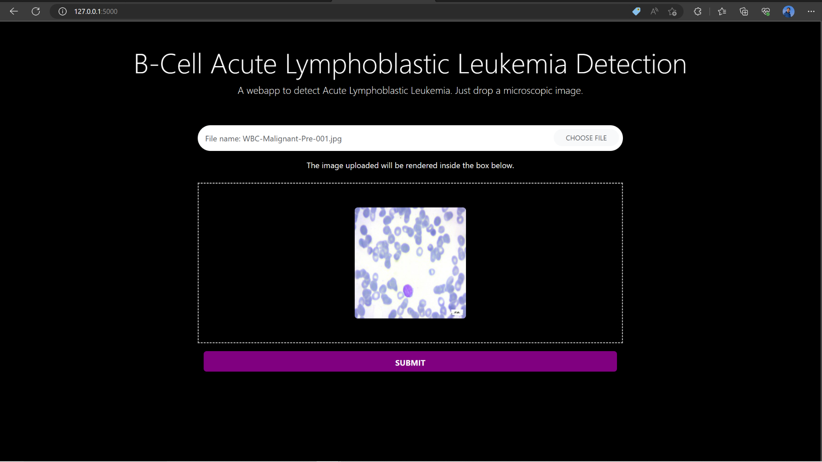

Fig 4.3 : Image Preview on Home Page of Infected Person’s Microscopic Image

After verification by the user, they need to submit the image using the given button. Once the image is submitted, the backend program triggers and starts to process the image. After completion of the backend process, a new page prompts the user whether the given image was of Infected Person or a Normal Person as shown in Fig 5.4 and 5.5 .

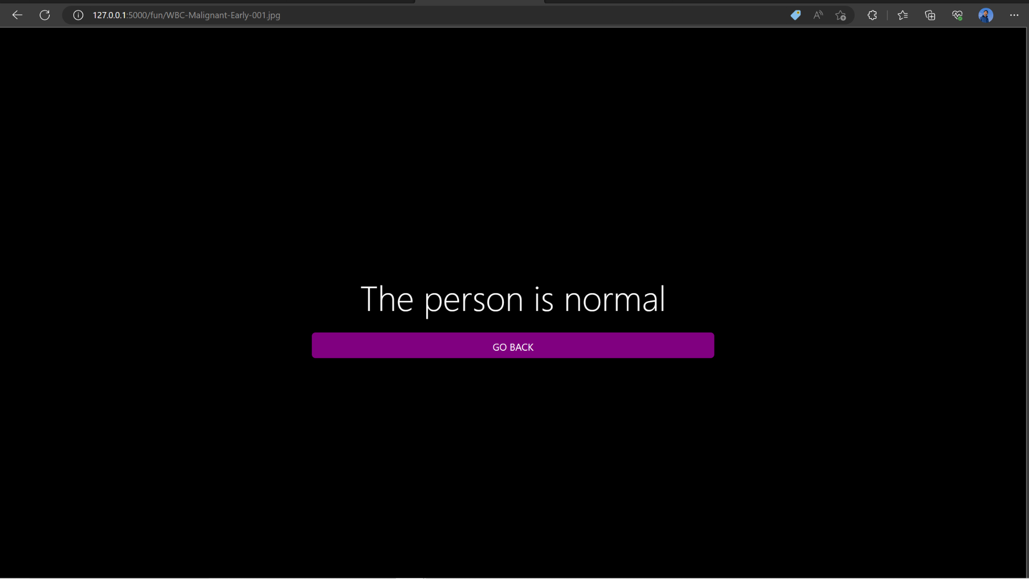

Fig 4.4 : The Person is Normal Prompt

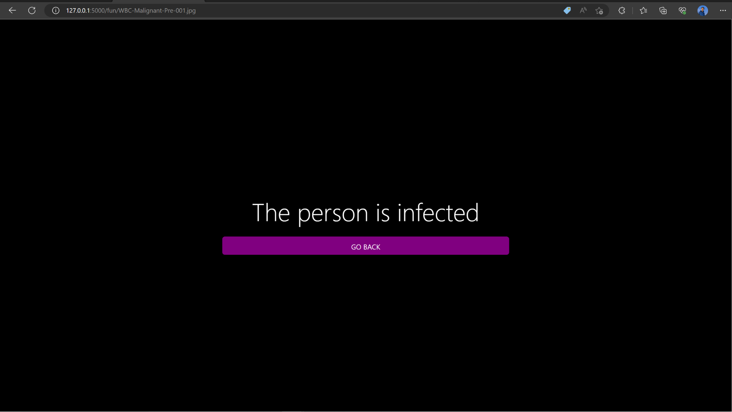

Fig 4.5 : The Person is Infected Prompt

**V. CONCLUSION**

This particular research project delved into exploring how using a CNN model and deep learning could be used to detect cases of B - ALL. The ability of the CNN model to distinguish between normal and leukemic cells with a remarkable 98% accuracy has been successfully demonstrated by our results.Performance evaluation based on measures like precision recall and F score together with area under curve (AUC) shows that this model is very effective at identifying B All type Leukemia. In consideration of factors such as accuracy, speed, robustness and generalizability, the CNN model performed better than other existing approaches.

**VII. ACKNOWLEDGEMENT**

We would like to thank Prof. Shital Dongre for her guidance and valuable inputs given during the making of the project.

We are also thankful to Vishwakarma Institute of Technology for providing us with the necessary facilities to implement the project.

**VIII. REFERENCES**

[1] Liang Z, Zhang S, Wang Y, et al. Automatic Acute Lymphoblastic Leukemia Diagnosis Using Artificial Intelligence. Sci Rep. 2020;10(1):1453. doi:10.1038/s41598-020-58243-3

[2] Khan SH, Gao J, Pandey P, et al. A Deep Learning Framework for Automatic Diagnosis of Childhood Acute Lymphoblastic Leukemia. Sci Rep. 2018;8(1):15192. doi:10.1038/s41598-018-33685-7

[3] Gómez-Paredes J, López-Mendoza O, Alcaraz-Mejía A, et al. An Automated System Based on Deep Learning for Fast and Accurate Diagnosis of B-ALL. J Biomed Inform. 2020;106:103444. doi:10.1016/j.jbi.2020.103444

[4] Awan AB, Zahra SA, Yaqoob I, Imran M, Javed MY. Deep Learning for Acute Lymphoblastic Leukemia Detection. Expert Syst Appl. 2021;181:115529. doi:10.1016/j.eswa.2021.115529

[5] Chen H, Qi X, Yu L, Yang J, Zhang Y, Xing E. Dual Transfer Learning for B-ALL Diagnosis on Peripheral Blood Smear Images. J Med Syst. 2017;41(7):114. doi:10.1007/s10916-017-0766-5

[6] Wang Q, Zhang Z, Huang K, Dong Y. A Deep Learning-Based Framework for Automatic Detection and Classification of Acute Lymphoblastic Leukemia Subtypes on Blood Smears. Int J Environ Res Public Health. 2020;17(21):8153. doi:10.3390/ijerph17218153

[7] Salehi M, Aryan N, Saeedizadeh N. Leukemia Recognition in Blood Microscopic Images Based on a Deep Learning Approach. J Med Signals Sens. 2019;9(1):52-59. doi:10.4103/jmss.JMSS_49_18